### Introduction

This report provides an insight into the development of the website considering the information security aspects and provides recommendation with respect to hosting, marketing, digital certificates, domain registration and CDN. It also provides an overview of different plug-ins and their uses

### The report is divided into section based on the topics of discussion.

**USER EXPERIENCE:**

The web application is build considering the requirements provide by the business owner, a secure staff page is created which is accessed only by authorized user, it asks for authentication and page is accessed only after successful authentication. The staff page provides roasters details and the contact details of the staff as per the requirement. The framework W3 CSS has been used to make the website responsive and dynamic, the use of framework makes the website easily maintainable, use friendly and accessible.

**INFORMATION SECURITY**

**Confidentiality** is mainly about making the information available and accessible to the authorized person or users. The general website information like the menu, bookings and location should be available to all users who visits the website. The weekly roaster and contact details of the staff and the owner should only be visible and accessible by the staff members or owner. The bookings and the customer details should be visible and accessible to authorized users only which can be the customer who are making the bookings or staff member with admin access who has privilege to make and change the booking for any customer on the customer’s behalf.

Customers and staff data may be stolen if hackers gain access to the user’s password or data, this will affect the business reputation and the organisation may be legally fined and incur huge loss. Un-authorized access can be prevented by using .htaccess configuration file, it controls access to pages within a directory by placing a .htaccess file in the directory. The .htaccess file contains the authentication username and password and is triggered when users try to access any pages within the specified directory, it first asks users to enter their login credentials to access the page. The file should be saved outside the www root directory which will prevent hackers from downloading the file.

**Integrity**: Maintaining consistency, accuracy and trustworthiness of data necessitates integrity, hackers may use their access or ability to intercept communications to modify staff or customer details. This may impact business in loss of data, can lead to violation of privacy act which may impose legal fine. Steps must be taken to ensure data is not changed while in transit, permissions must be set up for file transfer and user access control for users, The website staff user should be created with different access permission based on their role. Periodic backup of data should be maintained to avoid any data loss or inconsistency

**Authenticity** is assurance that a message, transaction, or other exchange of information is from the claimed source. The website is used for making reservation and purchasing voucher, hackers may pretend to be the restaurant website directing the customers to their fake site and getting them login with their login details. This can be prevented by having a digital certificate for the website. Digital certificates are issued by authorised organisations called Certificate Authorities (CA), this ensures the user is communicating to whom they expect to communicate rather than the hacker sitting in the middle of the communications

### **Possession or control:** Possession refers to the information being in the hand or control of whoever holds the physical control of the media in which data and information is stored. The possession can go into wrong hands like hackers, and they may use it for illegal purpose. For business it may impact the reputation and loss of trust from the customers. The website assets like images, web pages and data should be store in the encrypted format which will prevent the usage even if data is stolen unless it is decrypted which can only be done by the user with correct encryption key.

**Utility** refers to how useful the data is to us; hackers may gain access and insert or change the data like information of the customer or booking. The data is available for the business, but it is of no use. The impact of this could lead to losing accuracy of the data and breach of privacy act, such situation can be prevented if the web application use .htaccess for any rewrite, it will enforce authentication to make any changes only authorized user can make the changes.

**WEB HOSTING**

Following recommendations are being made based on the current requirement of the website and considering the future growth prospects.

* GoDaddy: is the world’s largest services platform for entrepreneurs around the globe. The package offered by GoDaddy which would be suitable for the Haukai restaurant website, the packages include free domain, supports cPanel along with the following features

|  |  |
| --- | --- |
| Package | Deluxe |
| Uptime | 99.9 % with guarantee |
| Customer Support | 24/7 for 365 days, email, phone and chat |
| Space | 50GB, unlimited traffic |
| Email storage | 5GB with one free mailbox |
| Refund | Full refund if cancelation is done within 30days |
| Cancelation /Termination | No extra charges provided cancelation is done as per their terms and conditions. |
| Cost | $8.49 p/m with min 3yrs terms |

* Crazy Domains: is a leading domain name registrar in Australia, Europe, India & Middle East. It is known for its simple business programme which allows manage and connect instantly to cloud based web hosting. The package offered by Crazy domain which could be suitable for the Haukai restaurant website, includes the following feature

|  |  |
| --- | --- |
| Package | Deluxe |
| Uptime | 99.9 % |
| Customer Support | 24/7 through email, phone and chat |
| Space | 150GB, traffic booster is optional |
| Email storage | 5GB |
| Refund | Full refund if cancelation is done within 60days |
| Cancelation /Termination | No extra charges provided cancelation is done as per their terms and conditions. |
| Cost | $10.50 p/m with 10yrs terms  $16.50 p/m with 3yrs terms |

Recommendation is for GoDaddy as it is cheap and reasonable and providing most of the useful features and service. Crazy Domains are costly if terms are shorter which is not economical for a start-up.

**MARKETING THE WEBSITE:**

Website is very crucial for any business since we are living in a digital world, without a website business may lose potential opportunities and customers. One of the most effective forms of advertising is web advertising because of its wider reach, to grow the business through digital marketing, more traffic needs to be driven to the website. The marketing strategy to drive more traffic to the website is to identify more suitable domain name for the website, use Banner Ads the restaurants website can be inserted inside the tourist website as a banner which can help in getting traffic to the website. Sponsored website and social media can also be used for marketing the website, social media has a very wider reach

Below is the domain name suggestion with the cost for registering from two different providers

|  |  |  |
| --- | --- | --- |
| GoDaddy | thehaukai.co.nz-cost $37.99 p/y | thehaukai.com-cost $9.99 p/y |
| Crazy Domain | Thehaukai.co.nz-cost $26 p/y | Thehaukai.com-cost $20 p/y |

The two search keywords which can be used for the websites are

* Māori Kai- this keyword is used for searching between 101-200 times per month
* Māori food - this keyword is used for searching between 501-850 times per month

The website pages title uses these keywords which helps for SEO purpose enabling the user to see the website details ranked on top based on the search keyword. Google and Bing can be used to submit the website for search engines.

For submitting the website for SEO using google the following link can be used: <https://www.google.com/webmasters/tools/submit> it is the URL for Google Search Console , this can be accessed through the google account , once logged in it will present the submission form asking for the website URL

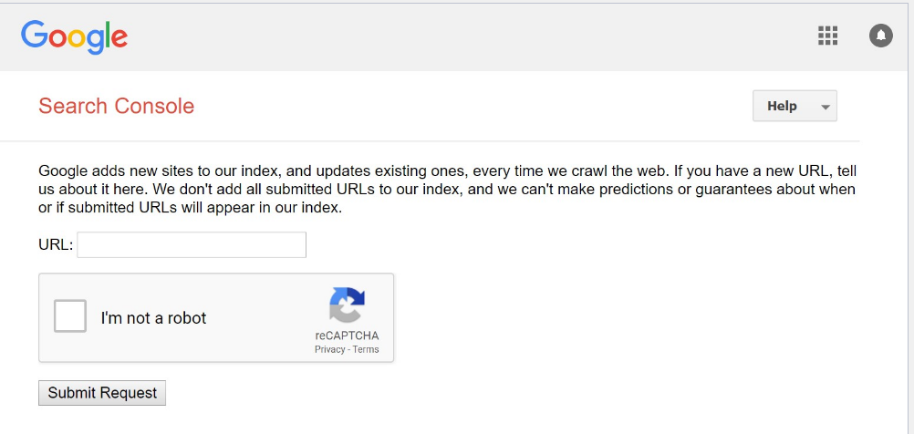

For submitting the website for SEO using Bing the following link can be used: <https://www.bing.com/toolbox/submit-site-url> .Bing doesn’t require to have an account, you can use the webmaster tool to submit the URL of the website.

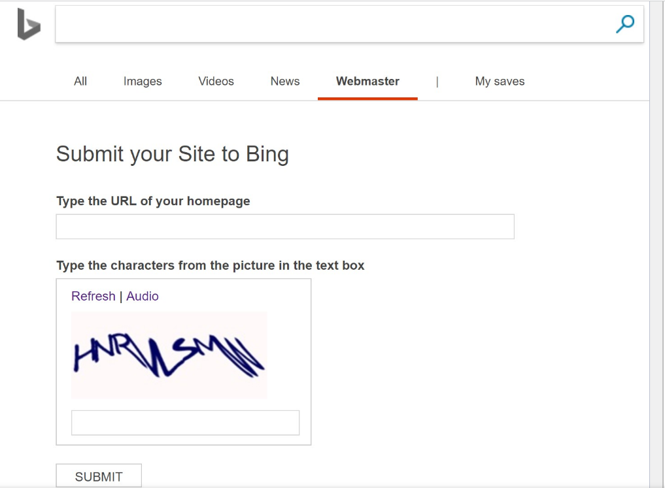

For advertising whether it for banner, sponsored or social media advertising it is generally based around competitive bidding in automated auctions against other advertisers. Google Ads can be used to place adverts based on bid pay-per-click or cost-per-click, keywords can be used to select ad group or campaign and target can be geographically and time wise, below is the average cost per click for Google Add based on our keyword maori food

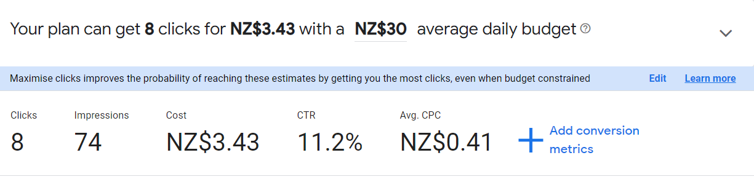

**SSL CERTIFICATE**

* GoDaddy also provides SSL certificate, Organisation validation SSL certificate which is ideal for a business like The Haukai restaurants. It provides high level of validation for the organisation; boost Google ranking also displays trust indicator on the address bar. The cost is $147.99 p/y for a two-year term with renewal cost of $184.99 in two years’ time.
* Digicert is another provider who issues SSL certificate, it also provides similar feature compared to GoDadyy. The cost is $448 for two-year plan.

Both the providers are quite well known so choosing the cheapest would be reasonable.

**CONTENT DELIVERY NETWORKS**

1. **Cloudflare’s** global cloud platform delivers a range of network services to businesses of all sizes around the world—making them more secure while enhancing the performance and reliability of their critical Internet properties.

The Business Plan of Cloudflare is of $200 p/m, providing unmetered mitigation of DDoS attacks with up to 100 Tbsp. capacity. They have 200 data centres across 200 cities to cache static content across Cloudflare’s global content delivery network. The Cloudflare supports customer SSL certificate to be uploaded, it also provides features for image optimization

1. **Imperva** Content Delivery Network (CDN) provides content caching, load balancing, and failover built natively into a comprehensive Web Application and API Protection (WAAP) platform. It has a range of plans, professional plans for smaller websites are $59 per month and businesses requiring SSL support and more priority support is $299 per month.

The owner is looking for more traffic and getting more visitor to the website, Cloudflare is a reasonable option providing the required service.

**PLUG-INS**

* **Prettier-Code Formatter**: this plug-in is free to install from VS Code marketplace it can make the code format which helps in maintaining, understanding and reusing the code, make sure to select the format on save from the setting which will enable code auto formatting when the file is save
* **Auto Rename Tag**: this plug-in is free to install from VS Code marketplace, it helps to code easily since it automatically changes the start and end tag if the tag name is changed.

### CONCLUSION

<https://www.staffhosteurope.com/blog/2019/03/cybersecurity-and-the-parkerian-hexad>

<https://www.godaddy.com/en-nz/hosting/windows-hosting>

<https://www.crazydomains.co.nz/windows-hosting/#section_specs,>

<https://www.velocityconsultancy.com/importance-of-website-reasons-why-your-business-needs-it/>

https://www.cloudflare.com/plans/business/